Zohaib Ahmad FA24-BCS-121

Assignment 1 — Your Personal CV Page
Difficulty: Foundational · Covers: Lectures 3–6 (HTML & HTML5, Semantic HTML and Forms, CSS Fundamentals, the CSS Box Model) · Folder: assignment-1/
Task: Build a single-page personal CV/résumé as a static HTML + CSS website — no JavaScript, no framework, just semantic HTML5 and hand-written CSS. This is where you prove you actually know the raw building blocks before anything is allowed to hide them from you.
Your page must include, at minimum:
- A header with your name, a short professional tagline, and a photo (a placeholder image is fine).
- An “About Me” section.
- An “Education” section listing your academic history in a semantic list or table.
- A “Skills” section.
- A “Contact” section with a real <a href="mailto:..."> link and at least one social/portfolio link.
- Correct use of semantic HTML5 elements throughout — <header>, <nav>, <main>, <section>, <article>, <footer> as appropriate, not a page built entirely out of unstyled <div>s.
- Styling entirely in a separate styles.css file (external stylesheet, not inline style="" attributes) using the box model correctly — sensible margins, padding, and borders, not everything jammed against everything else.

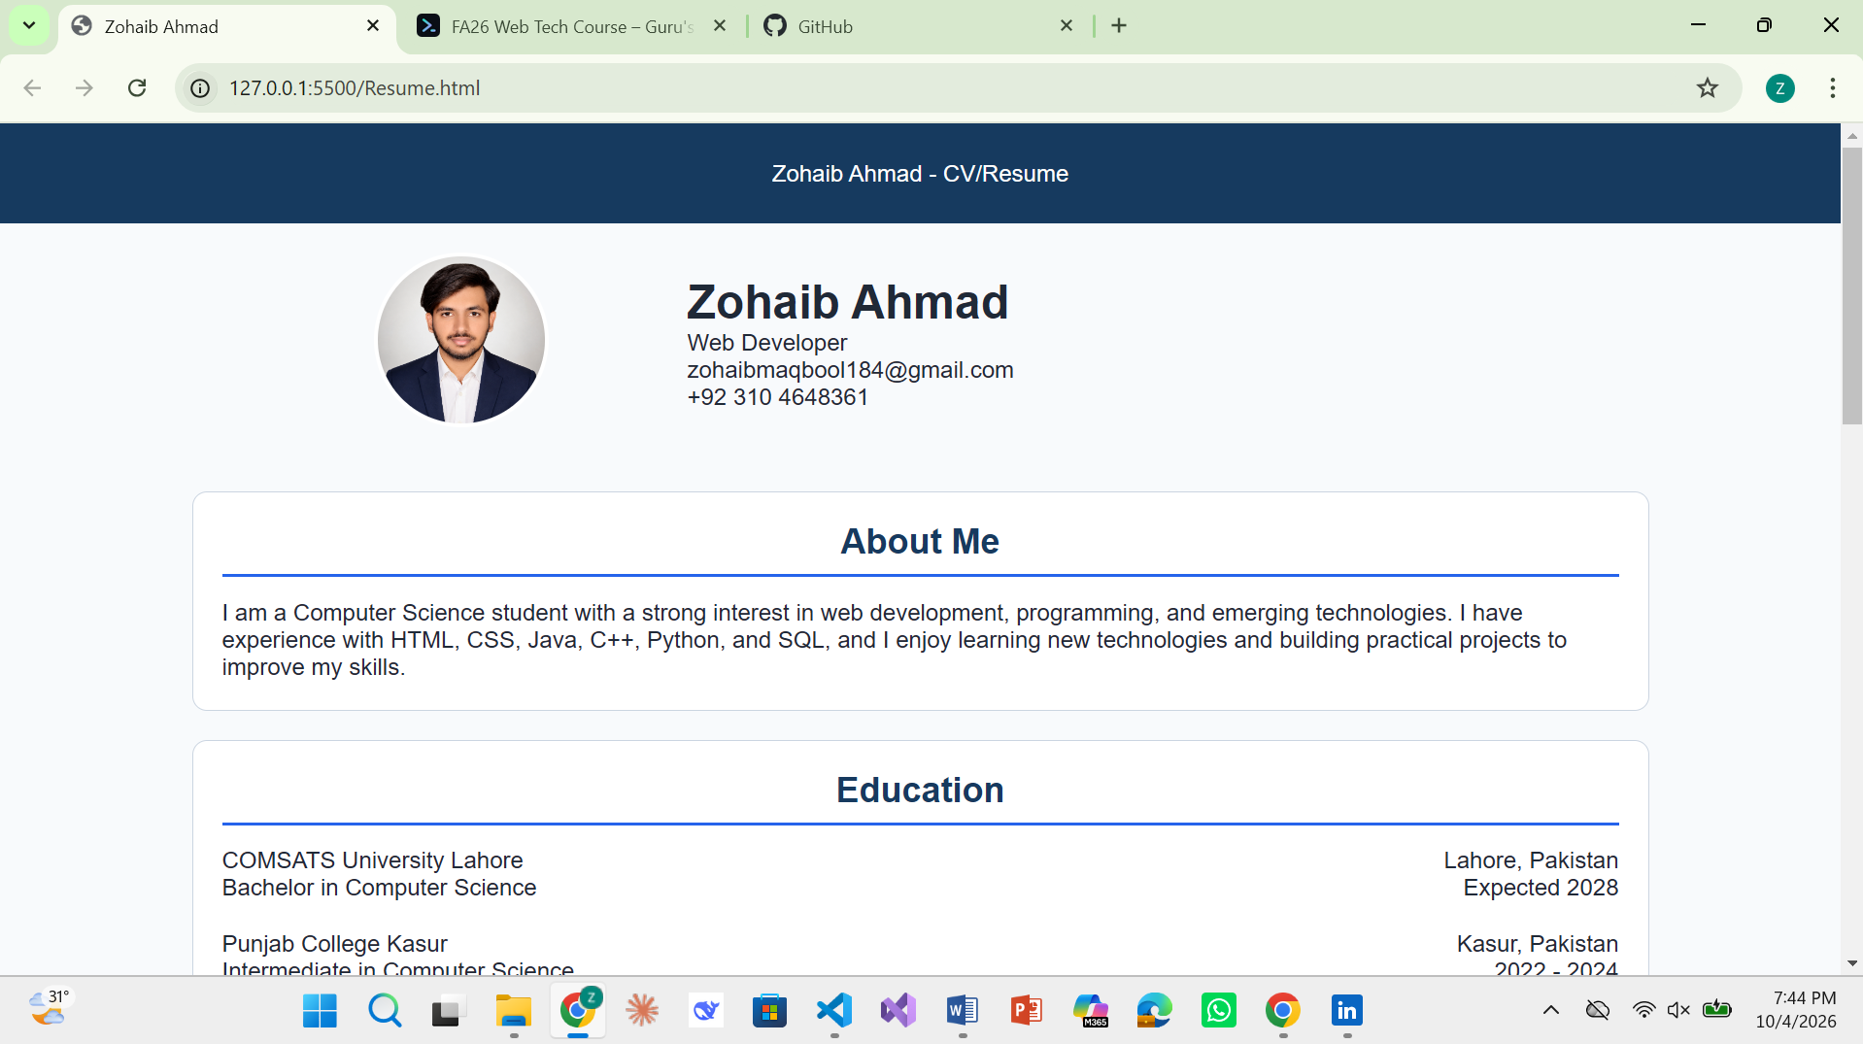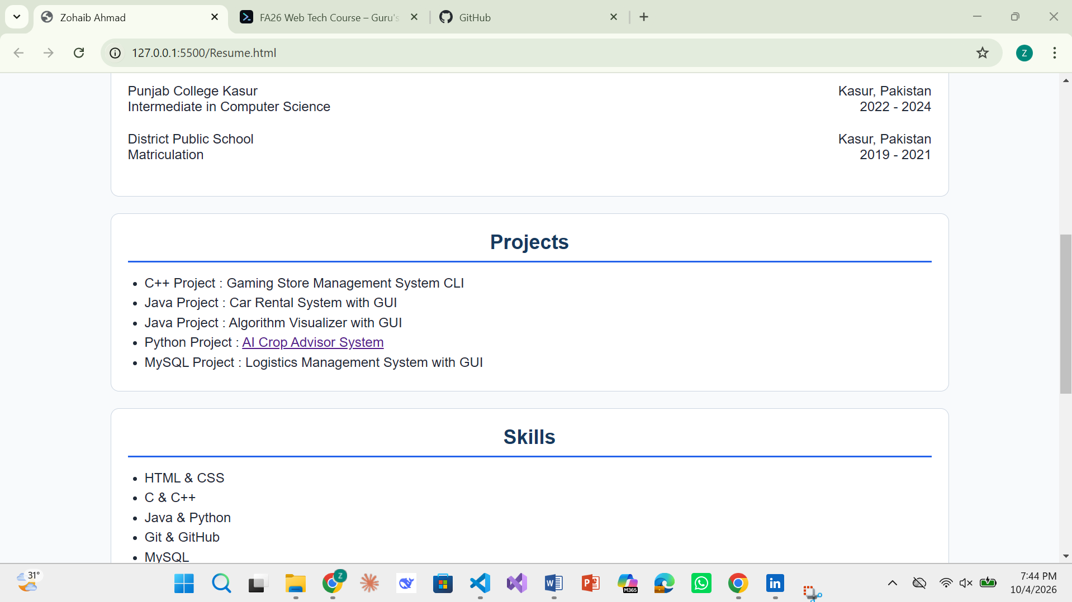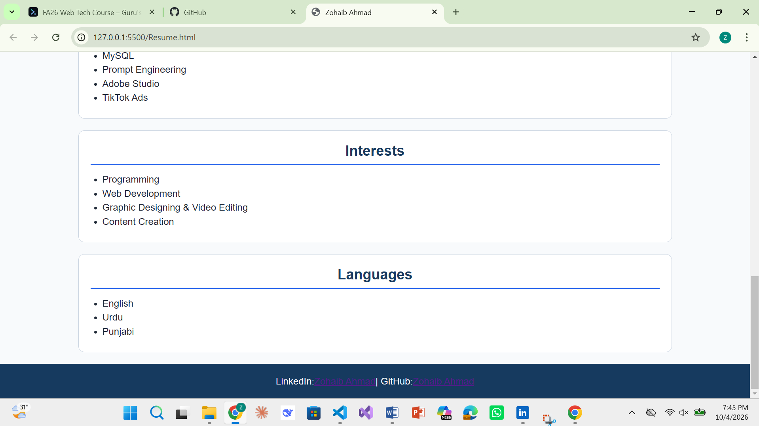

Resume.html:
<!DOCTYPE html>
<html lang="en">
<head>

<link rel="stylesheet" href="Style.css">

<meta charset="UTF-8">
<meta name="viewport" content="width=device-width, initial-scale=1.0">
<title>Zohaib Ahmad</title>
</head>
<body>
<header class="header">Zohaib Ahmad - CV/Resume</header>

<div class="Profile">

<div class="image-box">
<img src="Zohaib.jpg" class="Profile-Image" alt="Profile Image">
</div>

<div class="text-box">
<h1>Zohaib Ahmad</h1>
<p>Web Developer</p>
<p>zohaibmaqbool184@gmail.com</p>
<p>+92 310 4648361</p>
</div>
</div>

<div class="About">
<h2>About Me</h2>
<p>I am a Computer Science student with a strong interest in web development, programming, and emerging technologies. I have experience with HTML, CSS, Java, C++, Python, and SQL, and I enjoy learning new technologies and building practical projects to improve my skills.
</p>
</div>

<div class="Education">
<h2>Education</h2>
<table class="Education-table">
<tr>
<td>COMSATS University Lahore</td>
<td class="1">Lahore, Pakistan</td>
</tr>
<tr>
<td>Bachelor in Computer Science</td>
<td class="2">Expected 2028</td>
</tr>

<tr>
<td>Punjab College Kasur</td>
<td class="3">Kasur, Pakistan</td>
</tr>
<tr>
<td>Intermediate in Computer Science</td>
<td class="4">2022 - 2024</td>
</tr>

<tr>
<td>District Public School</td>
<td class="5">Kasur, Pakistan</td>
</tr>
<tr>
<td>Matriculation</td>
<td class="6">2019 - 2021</td>
</tr>
</table>
</div>

<div class="Projects">
<h2>Projects</h2>
<ul class="Projects-list">
<li>C++ Project : Gaming Store Management System CLI</li>
<li>Java Project : Car Rental System with GUI</li>
<li>Java Project : Algorithm Visualizer with GUI</li>
<li>Python Project : <a href="https://crop-advisory-system-pi.vercel.app/" target="_blank">AI Crop Advisor System</a></li>
<li>MySQL Project : Logistics Management System with GUI</li>
</ul>
</div>

<div class="Skills">
<h2>Skills</h2>
<ul class="Skills-list">
<li>HTML & CSS</li>
<li>C & C++</li>
<li>Java & Python</li>
<li>Git & GitHub</li>
<li>MySQL</li>
<li>Prompt Engineering</li>
<li>Adobe Studio</li>
<li>TikTok Ads</li>
</ul>
</div>

<div class="Interests">
<h2>Interests</h2>

<ul>
<li>Programming</li>
<li>Web Development</li>
<li>Graphic Designing & Video Editing</li>
<li>Content Creation</li>
</ul>
</div>

<div class="Language">
<h2>Languages</h2>
<ul class="Language-list">
<li>English</li>
<li>Urdu</li>
<li>Punjabi</li>
</ul>
</div>

<footer class="footer">
LinkedIn: <a href="https://www.linkedin.com/in/zohaibahmad284" target="_blank">Zohaib Ahmad</a> | GitHub: <a href="https://github.com/zohaib-maqbool" target="_blank">Zohaib Ahmad</a>
</footer>

</body>
</html>

Style.css
* {
margin: 0;
padding: 0;
box-sizing: border-box;
}

body {
font-family: 'Poppins', sans-serif;
background-color: #F8FAFC;
color: #1F2937;
}

h2 {
color: #163A5F;
border-bottom: 2px solid #2563EB;
padding-bottom: 8px;
margin-bottom: 15px;
text-align: center;
}

ul li {
list-style-type: disc;
margin-left: 20px;
margin-bottom: 5px;
}

.header {
width: 100%;
background-color: #163A5F;
color: white;
display: flex;
align-items: center;
justify-content: center;
padding: 25px;
}

.Profile {
display: flex;
width: 90%;
max-width: 900px;
margin: auto;
align-items: center;
}

.Profile-Image {
width: 120px;
height: 120px;
object-fit: cover;
border-radius: 50%;
border: 3px solid white;
}

.text-box {
width: 70%;
padding: 20px;
}

.image-box {
width: 30%;
padding: 20px;
text-align: center;
}

.About {
width: 90%;
max-width: 1000px;
margin: 20px auto;
padding: 20px;
background-color: #FFFFFF;
border-radius: 10px;
border: 1px solid #CBD5E1;
}

.Education {
width: 90%;
max-width: 1000px;
margin: 20px auto;
padding: 20px;
background-color: #FFFFFF;
border-radius: 10px;
border: 1px solid #CBD5E1;
}

.Education-table {
width: 100%;
border-collapse: collapse;
}

.Education-table tr:nth-child(2n) td {
padding-bottom: 20px;
}

.Education-table td:last-child {
text-align: right;
}

.Projects {
width: 90%;
max-width: 1000px;
margin: 20px auto;
padding: 20px;
background-color: #FFFFFF;
border-radius: 10px;
border: 1px solid #CBD5E1;
}

.Skills {
width: 90%;
max-width: 1000px;
margin: 20px auto;
padding: 20px;
background-color: #FFFFFF;
border-radius: 10px;
border: 1px solid #CBD5E1;
}

.Interests {
width: 90%;
max-width: 1000px;
margin: 20px auto;
padding: 20px;
background-color: #FFFFFF;
border-radius: 10px;
border: 1px solid #CBD5E1;
}

.Language {
width: 90%;
max-width: 1000px;
margin: 20px auto;
padding: 20px;
background-color: #FFFFFF;
border-radius: 10px;
border: 1px solid #CBD5E1;
}

.footer {
width: 100%;
background-color: #163A5F;
color: white;
display: flex;
align-items: center;
justify-content: center;
padding: 20px;
}

